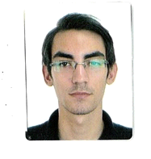

Skills
- Computer Skills  - Adaptability  - Fast learner | - Communication  - Innovative

Employment history
Customer Service Care - 02/2022 to 06/2022
Whitelab Services Kft. Budapest
- Communicated effectively with colleagues and superiors.
- Worked to achieve high customer satisfaction by providing optimal customer service.
- Brought forth a positive attitude and problem-solving abilities.
Quality Controller – 06/2023 to 09/2023
OLP Tech Kft. Miskolc
- Checked on welders.
- Prepare paper work.
- Helped solving problems.
Stocktaking (day labor) – 09/2023 to 09/2024
DWS Inventory Kft. Budapest
- Attention to detail.
- Communicating.
- organizational skills.
Transcriber – 09/2024 to current
Telus International Europe. Sofia, Bulgaria
- Help enhance the knowledge of AI program.

Education
Bláthy Ottó Electrotechnical School, High School Diploma
Sep 2013 – Jun 2017
Informatics System Maintenance Certificate
Bláthy Ottó Electrotechnical School, Higher Certificate
Sep 2017 – Jun 2018
IT System Administrator

Languages
English – B2
Other
B category driver’s license
Szabó
Imre
Phone:
+36 30 757 81 68
Email:
sz.imre98@gmail.com

